Verification

✅ What is Verification?
# Source: Chatgpt (GPT-5-Mini) at [1/20/2026]
Verification is the process of confirming that something is true, correct, or belongs to the person claiming it. In technology and online services, verification usually checks a user’s identity or information before allowing access to sensitive actions or accounts.

🔹 Types of Verification
# Source: Chatgpt (GPT-5-Mini) at [1/20/2026]
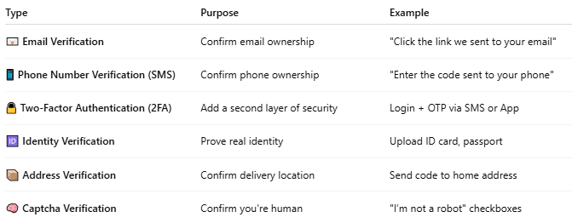

Type | Purpose | Example
📧 Email Verification | Confirm email ownership | "Click the link we sent to your email"
📱 Phone Number Verification (SMS) | Confirm phone ownership | "Enter the code sent to your phone"
🔒 Two-Factor Authentication (2FA) | Add a second layer of security | Login + OTP via SMS or App
🆔 Identity Verification | Prove real identity | Upload ID card, passport
📦 Address Verification | Confirm delivery location | Send code to home address
🧠 Captcha Verification | Confirm you're human | "I’m not a robot" checkboxes

🔸 Why is Verification Important?
# Source: Chatgpt (GPT-5-Mini) at [1/20/2026]
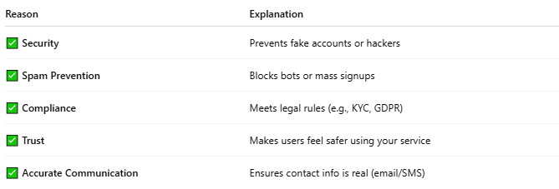

Reason | Explanation
✅ Security | Prevents fake accounts or hackers
✅ Spam Prevention | Blocks bots or mass signups
✅ Compliance | Meets legal rules (e.g., KYC, GDPR)
✅ Trust | Makes users feel safer using your service
✅ Accurate Communication | Ensures contact info is real (email/SMS)

🔸 Example: SMS Verification Flow
# Source: Chatgpt (GPT-5-Mini) at [1/20/2026]
- User signs up with a phone number.
- System sends an SMS with a code (e.g., Your code is 725314).
- User enters the code on the website/app.
- System checks the code — if correct, user is verified.

🛠️ Tech Used for Verification
# Source: Chatgpt (GPT-5-Mini) at [1/20/2026]
- Email Services: PHPMailer, SendGrid, SMTP
- SMS APIs: Twilio, Vonage, Plivo
- Verification Platforms: Auth0, Firebase Authentication
- CAPTCHA: Google reCAPTCHA

Verification VS Authentication
# Source: Chatgpt (GPT-5-Mini) at [1/20/2026]
Though they both deal with identity and access, verification and authentication are not the same. Here's a clear comparison:

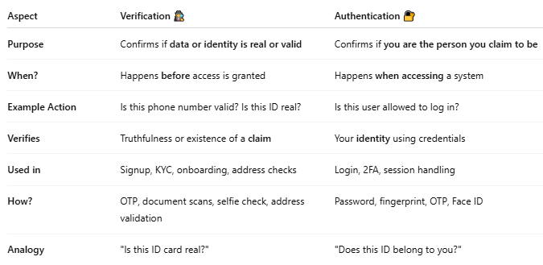

Aspect | Verification 🕵️‍♂️ | Authentication 🔐
Purpose | Confirms if data or identity is real or valid | Confirms if you are the person you claim to be
When? | Happens before access is granted | Happens when accessing a system
Example Action | Is this phone number valid? Is this ID real? | Is this user allowed to log in?
Verifies | Truthfulness or existence of a claim | Your identity using credentials
Used in | Signup, KYC, onboarding, address checks | Login, 2FA, session handling
How? | OTP, document scans, selfie check, address validation | Password, fingerprint, OTP, Face ID
Analogy | "Is this ID card real?" | "Does this ID belong to you?"

🔍 Examples
# Source: Chatgpt (GPT-5-Mini) at [1/20/2026]
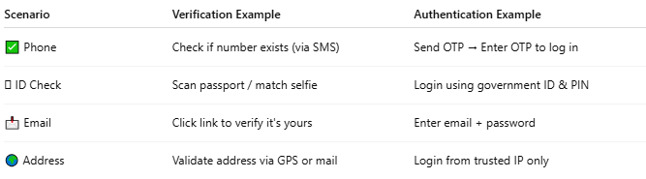

Scenario | Verification Example | Authentication Example
✅ Phone | Check if number exists (via SMS) | Send OTP → Enter OTP to log in
🪪 ID Check | Scan passport / match selfie | Login using government ID & PIN
📩 Email | Click link to verify it's yours | Enter email + password
🌍 Address | Validate address via GPS or mail | Login from trusted IP only

🔁 Together in Practice
# Source: Chatgpt (GPT-5-Mini) at [1/20/2026]
- Sign-up: System verifies your email or phone (Verification)
- Log in: You enter password or biometric (Authentication)
- High-risk action (e.g., money transfer): You complete OTP (Authentication step with verification)

🔐 Summary
# Source: Chatgpt (GPT-5-Mini) at [1/20/2026]
| ✅ Verification | Confirms validity of info or ID (one-time check) |
| 🔐 Authentication | Confirms you are you, allowing repeated access |

